**Agile Framework**

1. What is Agile
2. Agile Manifesto
3. 12 Principles of Agile
4. Key Components of Agile Methodology
5. Agile Software Development Process
6. Agile Frameworks
7. Agile Workflow
8. Agile in Real-Time

**What is Agile?**

Agile is a methodology primarily used in software development, emphasizing flexibility, collaboration, customer-centricity, and iterative progress. Unlike traditional project management methods, Agile focuses on delivering small, incremental changes to a project rather than a complete, finished product. This allows for faster adjustments, feedback incorporation, and value delivery.

(OR)

**Agile Methodology** is an iterative and incremental approach to project management and software development. It promotes flexibility, collaboration, and customer-centricity by breaking down projects into smaller, manageable units called "sprints" or "iterations." The goal is to deliver working software or products frequently, allowing teams to adapt to changes quickly and continuously improve based on feedback.

**Agile Manifesto**

The **Agile Manifesto**, created in 2001 by 17 software developers, sets the foundational values and principles of Agile. The manifesto prioritizes:

1. **Individuals and interactions over processes and tools.**



* + Collaboration and communication among team members are more important than strict adherence to tools and processes.

1. **Working software over comprehensive documentation.**
   * Delivering functional software is prioritized over exhaustive documentation.
2. **Customer collaboration over contract negotiation.**



* + Engaging the customer continuously throughout the project is valued more than rigid contract terms.

1. **Responding to change over following a plan.**



* + Flexibility and adaptability are prioritized over sticking to a predefined plan.

**12 Principles of Agile**

1. **Customer satisfaction through early and continuous delivery of valuable software.**
   * Deliver working software frequently, with a preference for a shorter timescale.
2. **Welcome changing requirements, even late in development.**
   * Agile processes harness change for the customer’s competitive advantage.
3. **Deliver working software frequently, from a couple of weeks to a couple of months, with a preference to the shorter timescale.**
   * This principle encourages regular delivery of updates to ensure continuous feedback.
4. **Business people and developers must work together daily throughout the project.**
   * Collaboration between stakeholders and developers is crucial for success.
5. **Build projects around motivated individuals. Give them the environment and support they need and trust them to get the job done.**
   * Trust and empower the team to take ownership of their work.
6. **The most efficient and effective method of conveying information to and within a development team is face-to-face conversation.**
   * Direct communication reduces misunderstandings and speeds up problem-solving.
7. **Working software is the primary measure of progress.**
   * Deliverable software is a key indicator of success.
8. **Agile processes promote sustainable development.**
   * Maintain a constant pace indefinitely, avoiding burnout.
9. **Continuous attention to technical excellence and good design enhances agility.**
   * High-quality code and design improve adaptability and reduce technical debt.
10. **Simplicity—the art of maximizing the amount of work not done—is essential.**
    * Focus on essential tasks and avoid unnecessary work.
11. **The best architectures, requirements, and designs emerge from self-organizing teams.**
    * Allow teams to manage themselves and make decisions.
12. **At regular intervals, the team reflects on how to become more effective, then tunes and adjusts its behaviour accordingly.**
    * Continuous improvement through regular reflection.



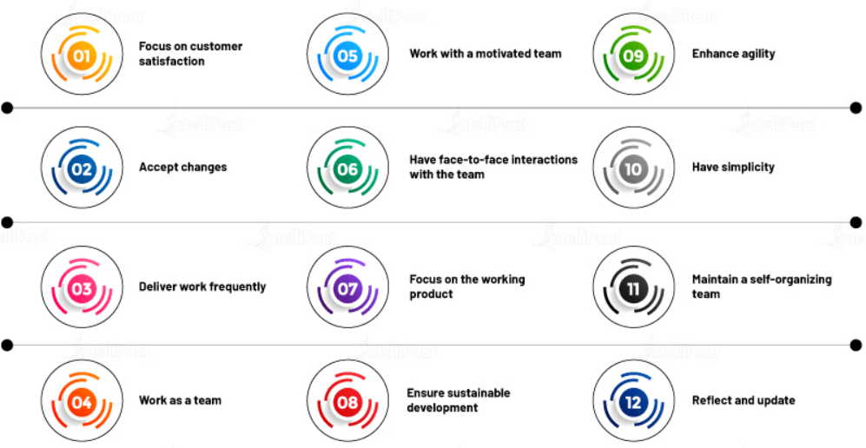

**Key Components of Agile Methodology**

1. **Iterations (Sprints):**
   * Short, time-boxed periods (usually 1-4 weeks) where a specific set of features or tasks are completed and delivered.
2. **Backlog:**
   * A prioritized list of work items (features, bugs, enhancements) that the team plans to complete in future iterations.
3. **Daily Stand-Ups:**
   * Short, daily meetings where team members discuss progress, obstacles, and plans for the day. These meetings promote transparency and quick problem-solving.
4. **Incremental Delivery:**
   * Delivering small, functional pieces of the product at the end of each iteration. This ensures that the project is always progressing and provides value early and often.
5. **Continuous Feedback:**
   * Incorporating feedback from stakeholders after each iteration to refine the product and improve future work.
6. **Retrospectives:**
   * Meetings held at the end of each iteration to reflect on what went well, what could be improved, and how the team can enhance their processes.

**Agile Software Development Process**

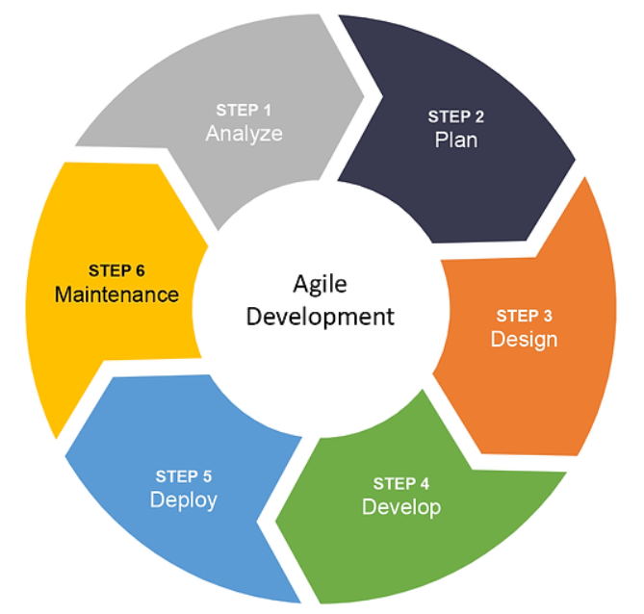

**Agile Frameworks**

There are several frameworks under the Agile umbrella, each tailored for different types of projects:

1. **Scrum:**
   * A popular Agile framework that uses fixed-length sprints to build and deliver software incrementally. Key roles include the Scrum Master, Product Owner, and Development Team.
2. **Kanban:**
   * A visual approach to managing work, where tasks are represented on a board and moved through stages like "To Do," "In Progress," and "Done." It focuses on continuous delivery and limiting work in progress (WIP).



1. **Lean:**
   * Focuses on eliminating waste, optimizing processes, and delivering value to the customer with minimal effort.
2. **Extreme Programming (XP):**
   * Emphasizes technical excellence and frequent releases. Key practices include pair programming, test-driven development, and continuous integration.
3. **SAFe (Scaled Agile Framework):**
   * A framework designed to scale Agile across large enterprises, incorporating roles, responsibilities, and processes at the team, program, and portfolio levels.

**The Agile Workflow**

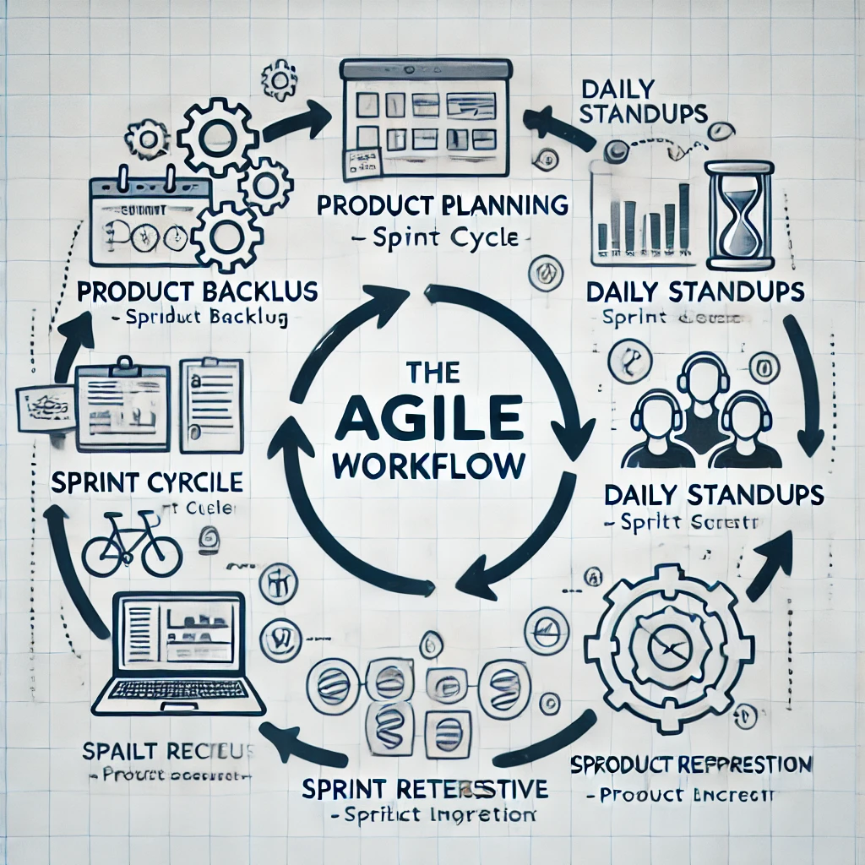



**Agile in Real-Time: Examples**

Agile is widely used across industries for various projects, not just in software development. Here are some real-world examples of Agile in action:

1. **Software Development: Scrum in a Tech Company**
   * **Situation:** A tech company develops a mobile app with weekly sprints.
   * **Process:** The team uses the Scrum framework, holding daily stand-ups, sprint planning, and retrospectives. Each sprint results in a working version of the app, which is then demonstrated to the product owner for feedback.
   * **Outcome:** The app evolves iteratively, with new features added based on continuous feedback.
2. **Product Development: Kanban in a Manufacturing Company**
   * **Situation:** A manufacturing firm uses Kanban to manage its production process.
   * **Process:** The team visualizes tasks on a Kanban board, moving work items through stages like "To Do," "In Progress," and "Done." This system allows for real-time adjustments based on demand and resource availability.
   * **Outcome:** Improved workflow efficiency and reduced bottlenecks.
3. **Marketing Campaigns: Agile in a Digital Marketing Agency**
   * **Situation:** A digital marketing agency runs Agile marketing campaigns.
   * **Process:** The team breaks down campaigns into two-week sprints, focusing on specific channels like social media, SEO, or content marketing. After each sprint, results are analysed, and strategies are adjusted accordingly.
   * **Outcome:** Faster adaptability to market changes and higher client satisfaction.